Name:A.Shashidhar H.No:2303A51798 Batch:26
SCHOOL OF COMPUTER SCIENCE AND ARTIFICIAL INTELLIGENCE |  |  |  |  | DEPARTMENT OF COMPUTER SCIENCE ENGINEERING
Program Name:B. Tech |  |  |  | Assignment Type: Lab |  |  | Academic Year:2025-2026
Course Coordinator Name |  |  |  | Dr. Rishabh Mittal
Instructor(s)Name |  |  |  | Mr. S Naresh Kumar  Ms. B. Swathi  Dr. Sasanko Shekhar Gantayat  Mr. Md Sallauddin  Dr. Mathivanan  Mr. Y Srikanth  Ms. N Shilpa  Dr. Rishabh Mittal (Coordinator)  Dr. R. Prashant Kumar  Mr. Ankushavali MD  Mr. B Viswanath  Ms. Sujitha Reddy  Ms. A. Anitha  Ms. M.Madhuri  Ms. Katherashala Swetha  Ms. Velpula sumalatha  Mr. Bingi Raju  Mr. G. Kranthi
Course Code |  |  | 23CS002PC304 | Course Title |  | AI Assisted Coding
Year/Sem |  |  | III/I | Regulation |  | R23
Date and Day  of Assignment |  |  | Week 7 - Thursday | Time(s) |  | 23CSBTB01 To 23CSBTB52
Duration |  |  | 2 Hours | Applicable to  Batches |  | All Batches
AssignmentNumber:14.4 (Present assignment number)/24(Total number of assignments)
 | Q.No. | Question |  |  |  |  |  | ExpectedTime  to complete
 | 1 | Lab 14: Web Frontend Development – AI-Assisted HTML/CSS/JS Generation  Lab Objectives  - Design functional, visually appealing web applications using HTML, CSS, and JavaScript with AI assistance.  - Apply responsive, accessible, and interactive design principles.  - Create practical UI components for real-world web applications.  - Use AI to optimize layout, UX, and performance.  Lab Outcomes  - Applying AI assistance to frontend development tasks  - Understanding how HTML, CSS, and JavaScript work together  - Improving responsiveness, interactivity, and usability  - Evaluating and refining AI-generated frontend code |  |  |  |  |  | Week 7

Task 1: Responsive Homepage Layout for a Startup Website

Scenario
You are designing a basic homepage for a startup company that needs to look good on desktops, tablets, and mobile devices.

Task Description
- Create a web page structure using HTML that includes:
  - A header with navigation links
  - A main content section
  - A footer with basic information
- Use AI assistance to generate responsive CSS using media queries.
- Ensure the layout adjusts smoothly across different screen sizes.

Expected Output
- A responsive web page where:
  - Header, content, and footer are clearly separated
  - Layout adapts correctly to mobile, tablet, and desktop views
  - Code is clean and well-structured
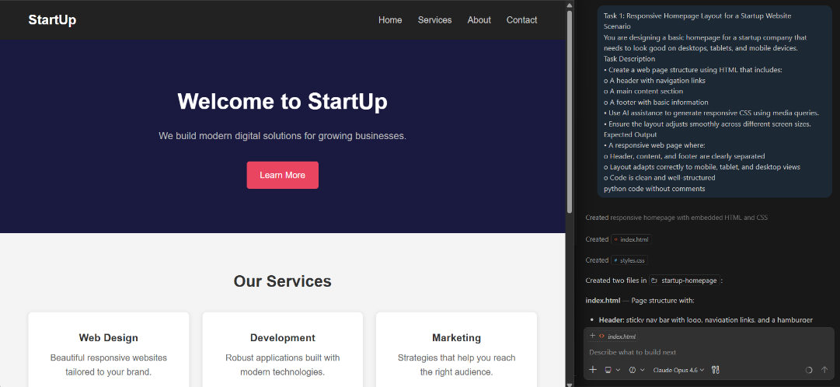

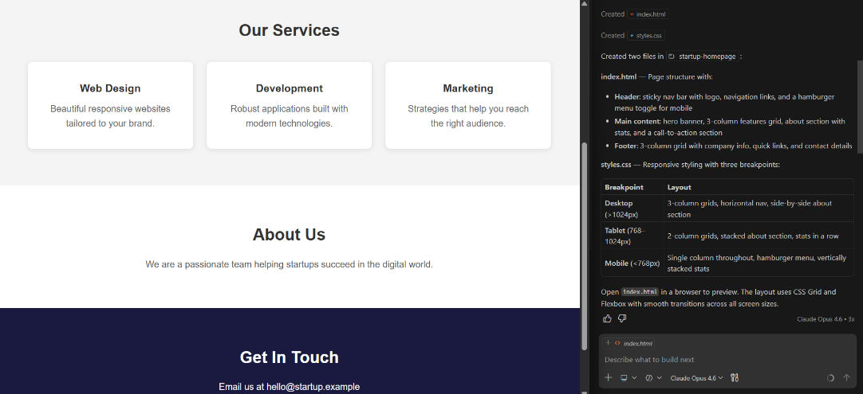

Task 2: Interactive Call-to-Action Button

Scenario
A marketing page requires a call-to-action button that responds when users interact with it.

Task Description
- Add a button to a web page using HTML.
- Use AI to generate JavaScript that responds to the button click by:
  - Displaying a message or alert
- Ask AI to add meaningful comments explaining the JavaScript logic.

Expected Output
- A web page where:
  - Clicking the button triggers a visible response (alert or message)
  - JavaScript code is readable and commented
  - No page reload occurs

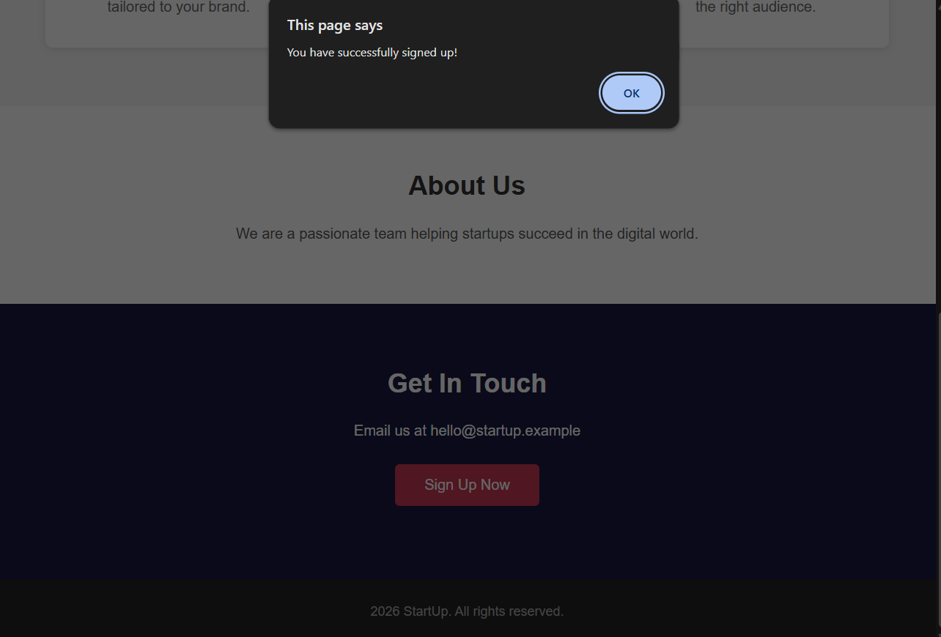
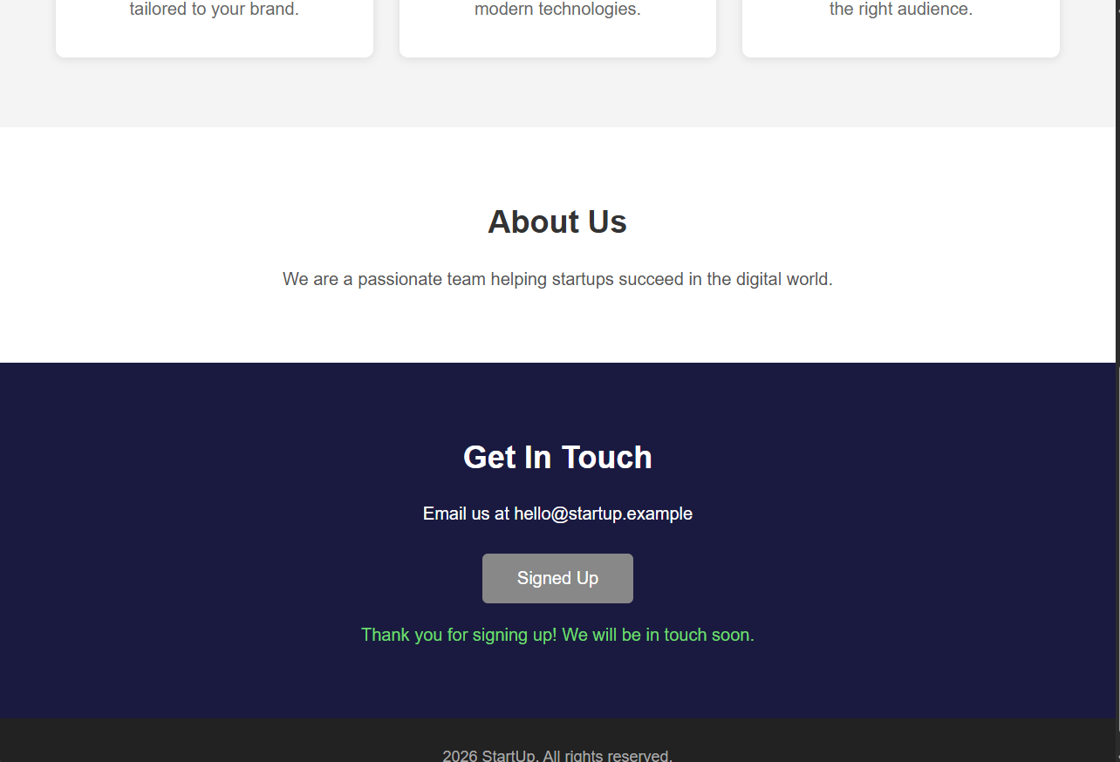

Task 3: Contact Form with Client-Side Validation

Scenario
You are developing a contact form for a company website to collect user queries safely and correctly.

Task Description
- Design a form with fields for:
  - Name
  - Email
  - Message
- Use AI to generate JavaScript validation logic that:
  - Prevents empty submissions
  - Checks for a valid email format
- Display clear error messages for invalid input.

Expected Output
- A functional form where:
  - Invalid input shows inline error messages
  - Valid input displays a success message
  - Validation happens on the client side using JavaScript
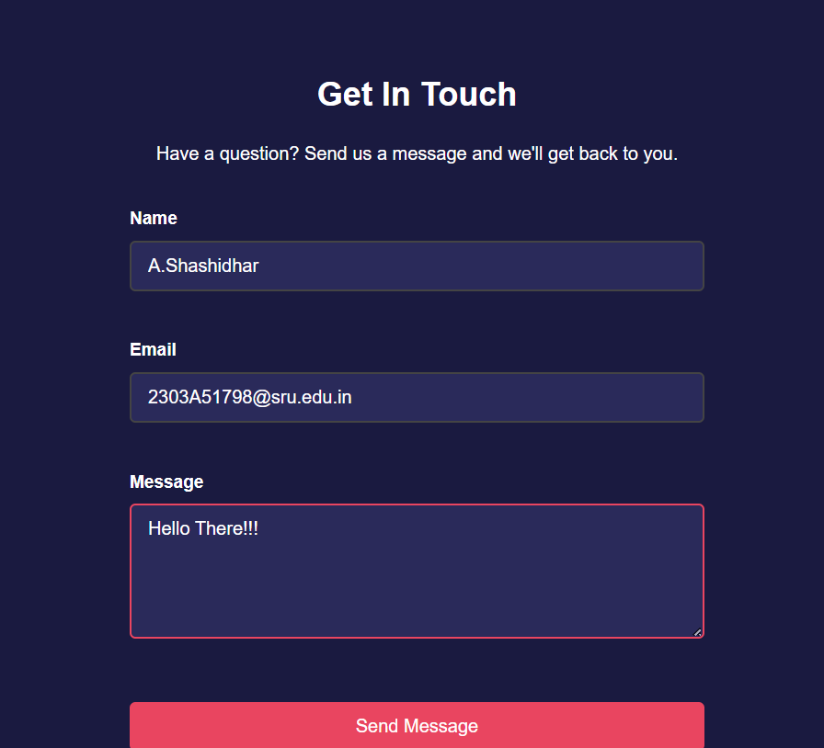
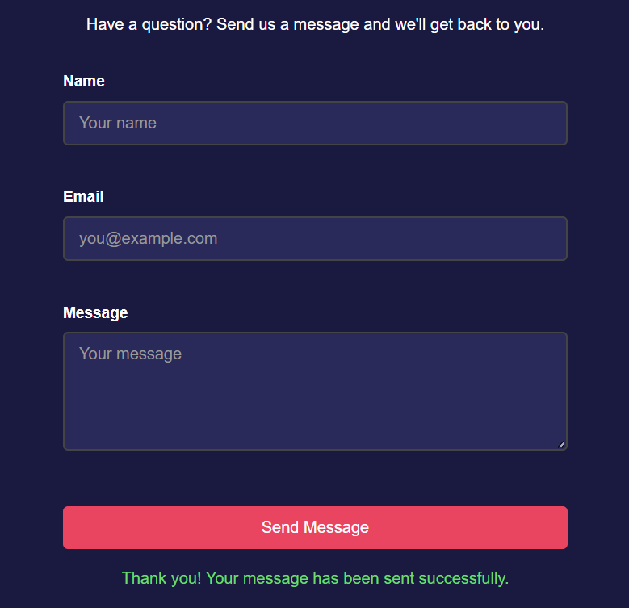

Task 4: Dynamic List Management for a Product Page

Scenario
A product listing page needs to add or remove items dynamically without refreshing the page.

Task Description
- Create a simple HTML list to display items.
- Use AI to generate JavaScript that:
  - Adds a new item when an “Add” button is clicked
  - Removes the last item when a “Remove” button is clicked
- Ensure the DOM updates dynamically.

Expected Output
- A web page where:
  - Items can be added and removed dynamically
  - Changes appear instantly without page reload
  - JavaScript logic is clear and maintainable

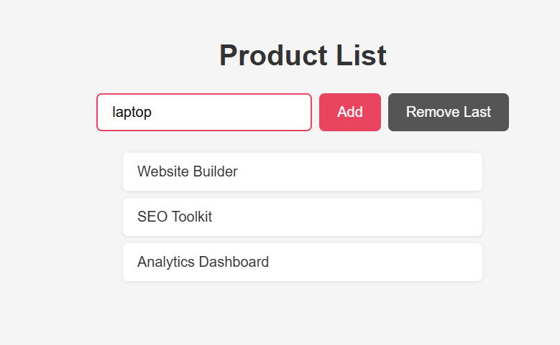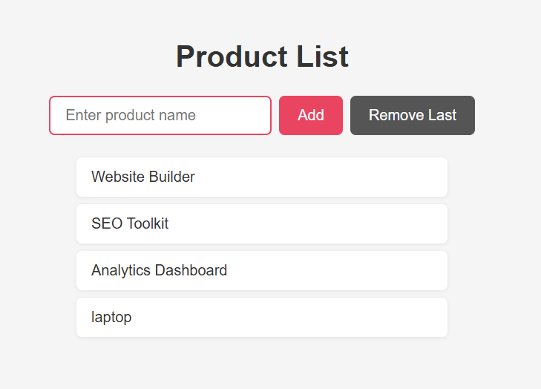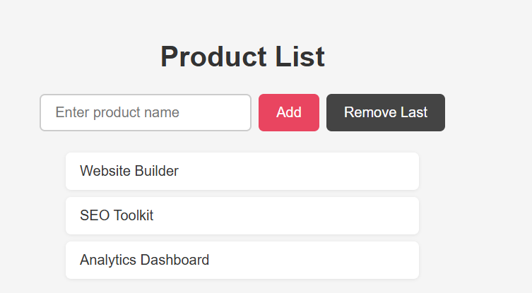

Task 5: Modal Popup for User Notifications

Scenario
You are building a user notification popup for announcements or alerts on a website.

Task Description
- Use AI to help generate:
  - HTML structure for a modal popup
  - CSS styling with a semi-transparent background overlay
  - JavaScript to open and close the modal
- Include multiple ways to close the modal (button or overlay click).

Expected Output
- A web page where:
  - Clicking “Open Modal” displays the popup
  - Popup overlays the page content clearly
  - Modal closes smoothly when instructed
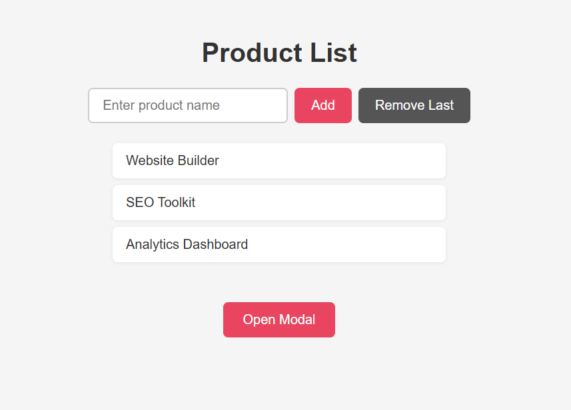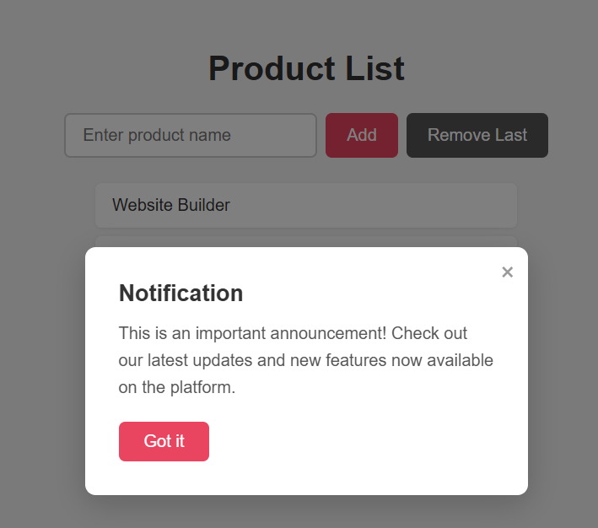

Note: Report should be submitted a word document for all tasks in a single document with prompts, comments & code explanation, and output and if required, screenshots

